****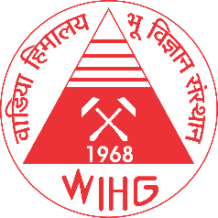 REGISTRATION FORM

**8th NATIONAL GEO-RESEARCH**

**SCHOLARS MEET 2024**

22-25 November, 2024

At

**Shri Mata Vaishno Devi University (SMVDU) Campus,  
Sub-Post Office, Katra,  
Jammu and Kashmir – 18232**

|  |  |  |  |  |  |  |  |
| --- | --- | --- | --- | --- | --- | --- | --- |
| 1. Applicant Name | Initial (Dr./Mr./Ms.) | Last Name | | First Name | | | Middle Name |
| 1. Father’s Name |  | | | | | | |
| 1. Date of Birth | DD | MM | | | YYYY | | |
| 1. Gender (M/F) |  | | | | | | |
| 1. Corresponding address |  | | | | | | |
| 1. E-mail ID |  | | | | | | |
| 1. Name of Theme |  | | | | | | |
| 1. Academic Qualification (PhD) | Awarded | Submitted | | | ongoing | | |
| 1. Research Experience (mm, yy) | Months | | | Years | | | |
| 1. Research papers (SCI Journals) | Published | | Accepted | | | Communicated | |
| 1. Host Institution/ University |  | | | | | | |
| 1. Supervisor / HOD    1. Name    2. E-Mail ID    3. Contact No |  | | | | | | |
| 1. A brief outline of present research activity with its future prospects (max. 200 words) |  | | | | | | |
| 1. A brief note on “How will you be benefitted by this meet” (Mention in the attach word file) |  | | | | | | |
| 1. Accommodation requirement (Yes/No) |  | | | | | | |
| 1. Have you attended the earlier National Geo- Research Scholar Meet (NGRSM) |  | | | | | | |

Date : Signature of the applicant

Place:

Signature of Head of Group/Department (with office seal)